# Appendix 3: Country case study reports (Colombia, Fiji)

These are the case study reports from the country missions to Colombia and Fiji.

Case Study Report: Assessing the availability of data and indicators in Colombia for a compilation of best practices in measuring the oceans

Contents

Acronym list 2

Introduction 3

Stakeholders meeting 3

Interviews 4

Colombia’s approach for monitoring and reporting progress on SDG 14 4

Indicator 14.1.1 Index of Coastal Eutrophication (ICEP) and floating plastic debris density 7

Target 14.1 By 2025, prevent and significantly reduce marine pollution of all kinds, in particular from land-based activities, including marine debris and nutrient pollution 7

Indicator 14.2.1 Proportion of national exclusive economic zones managed using ecosystem-based approaches 10

Indicator 14.5.1 Coverage of protected areas in relation to marine areas 13

Users of data and data-derived information at the national level 14

What to include on the Global Manual on Ocean Statistics 15

References 16

Annexes 17

Annex 1 Colombia visit agenda 17

Annex 2 Interviewees list 18

# Acronym list

|  |  |
| --- | --- |
| **Acronym** | **English name** |
| ANLA | National Authority of Environmental Licences |
| CAR | Regional Autonomous Corporations |
| CCO | Colombian Ocean Commission |
| DANE | National Administrative Department of Statistics |
| GIS | Geographic Information System |
| ICAM | Indicator on the Quality of Marine and Coastal Waters |
| ICEP | Index of Coastal Eutrophication |
| ICZM | Integrated Coastal Zone Management |
| IDEAM | Institute of Hydrology, Meteorology and Environmental Studies |
| INVEMAR | Marine and Coastal Research Institute |
| ISO | International Organization for Standardization |
| MADS | Ministry of Environment and Sustainable Development |
| MPA | Marine Protected Area |
| NBSAP | *National Biodiversity Strategies and Action Plan* |
| NOAA | National Oceanic and Atmospheric Administration |
| OAT | Environmental Territorial Ordinance Plans |
| OHI | Ocean Health Index |
| PNAOCI | National Environmental Policy for the Sustainable Development of Ocean Spaces, Islands and Coastal Areas |
| PNN | National Natural Parks of Colombia |
| PNOEC | National Policy on Oceans and Coastal Spaces |
| REDCAM | Marine and Coastal Water Quality Monitoring Network of Colombia |
| RUNAP | National Registry of Protected Areas |
| SDG | Sustainable Development Goals |
| SINAP | National System of Protected Areas |
| UACO | Coastal and Oceanic Environmental Units |
| UNEP | United Nations Environment Programme |
| UNEP - ROLAC | United Nations Environment - Regional Office for Latin America and the Caribbean |
| UNEP - WCMC | United Nations Environment– World Conservation Monitoring Centre |
| UNESCO | United Nations Educational, Scientific and Cultural Organization |
| UPB | Pontificia Bolivariana University |
| WDPA | World Database on Protected Areas |

# Introduction

This report presents proceedings from a visit to Colombia, which had the objective of assessing the availability of data and indicators for a compilation of best practices to track progress towards Sustainable Development Goal (SDG) 14 (Life below water). The four-day visit ran from the 18th to 21st of September 2017, and included a stakeholders meeting and individual interviews with relevant institutions (see agenda in Annex 1). The mission was led by Elisabetta Bonotto (UN Environment, Science Division), Juan Bello (UN Environment Regional Office for Latin America and the Caribbean, UNEP-ROLAC), and Katherine Despot-Belmonte (UN Environment World Conservation Monitoring Centre, UNEP-WCMC).

The purpose of the visit was to gather best practices from Colombia with regards to data flows, indicators, and methodologies for data collection and indicator calculation within the country, for each of the three global indicators for which UN Environment is the custodian agency (14.1.1, 14.2.1, 14.5.1). The main objective was to identify best practices in Colombia that could be useful for other countries in terms of development of country-relevant methodologies to track progress towards SDG indicators 14.1.1. *Index of Coastal Eutrophication (ICEP) and floating plastic debris density*, 14.2.1 *Proportion of national exclusive economic zones managed using ecosystem-based approaches*, and 14.5.1. *Coverage of protected areas in relation to marine areas*. The visit was also an opportunity to inform the development and applicability of the step-by-step methodologies that are presented elsewhere in the Global Manual on Ocean Statistics.

## Stakeholders meeting

This meeting took place in the premises of the Ministry of Environment and Sustainable Development (MADS), in Bogota – Colombia. The meeting was convened by Santiago Arango Botero (MADS), along with Elisabetta Bonotto, Juan Bello and Katherine Despot-Belmonte. Sixteen participants attended the meeting, and they represented both data producers and data users from different government institutions, such as the Ministry of Environment and Sustainable Development (MADS in Spanish), the Ministry of Foreign Affairs (a.k.a. Cancillería), the National Administrative Department of Statistics (DANE in Spanish), National Natural Parks of Colombia (PNN in Spanish), the Colombian Ocean Commission (CCO in Spanish); as well as universities/research institutes such as the Marine and Coastal Research Institute (INVEMAR in Spanish), the Institute of Hydrology, Meteorology and Environmental Studies (IDEAM in Spanish) and the University Pontificia Bolivariana (UPB in Spanish).

The meeting began with a round of introductions, followed by brief presentations from Elisabetta Bonotto and Juan Bello that provided some background on the purpose of the visit, the SDG monitoring and reporting process, the role of UN Environment as custodian agency, the Global Manual on Ocean Statistics, and the role of Colombia as a case study. The second part of the meeting was interactive and focused on a mapping exercise with all stakeholders to map data flows from collection to analysis for SDG 14 indicators 14.1.1, 14.2.1, and 14.5.1. Participants were provided with blank diagrams of the *Framework for an environmental information system for NBASP (National Biodiversity Strategies and Action Plan) implementation and SDG achievement* (Figure 1 below). The outcomes of the mapping exercise are shown in Figures 3, 6, 7 of this report.

Figure 1: Framework for an environmental information system for NBSAP (National Biodiversity Strategies and Action Plan) implementation & SDG achievement (UNEP-WCMC, 2016).



## Interviews

###### The interviews with data/indicator producers (i.e. PNN and INVEMAR) helped to identify which indicators and methodologies (including targets and thresholds) Colombia is currently using, what institutions are involved in the production of data, why specific approaches were chosen, what is working well, and what the limitations and challenges for indicator development are. The interviews with users of data (i.e. MADS, DANE, Cancillería, CCO) helped to identify who will make use of data/indicators for reporting or other purposes.

###### Overall, the interviews along with discussions and outputs from the stakeholder meeting helped to document the indicator cycle from data collection to reporting, assessing the existing capacity for indicator development in Colombia, and identifying mandates and the different institutions involved.

# Colombia’s approach for monitoring and reporting progress on SDG 14

Colombia has adopted a *National Development Plan* 2014-2018[1], which incorporates the vision and principles of the 2030 Agenda for sustainable development. The *National Development Plan* includes strategies, actions and some indicators towards implementing and monitoring progress on the different SDGs. The Plan has a strong focus on the implementation of the 2030 Agenda at the sub-national level through local development plans (a.k.a. Territorial Development Plans), which are led by local governments and local environmental authorities (a.k.a. Regional Autonomous Corporations – CAR in Spanish) [2].

Colombia has set up a national SDG Commission[3] for the effective implementation of Agenda 2030 and the SDGs. The SDG Commission is mandated with steering the implementation of the 2030 Agenda at a high-level through public policies, plans, programs and actions. The SDG Commission is composed of seven government institutions: the Presidency of the Republic, Ministry of Finance, Ministry of Foreign Affairs, Ministry of Environment and Sustainable Development, National Planning Department, National Department of Statistics.

With regards to monitoring and reporting on progress towards SDG 14, the Ministry of Environment and Sustainable Development (MADS) and the National Department of Statistics (DANE) play a leading role in terms of compiling data/information that can feed into SDG 14 indicators. MADS liaises with data/information producers to inform decisions and policies, and is tasked with coordinating efforts to ensure that available data are used to report progress on Targets 14.1, 14.2, and 14.5[4].

DANE coordinates the National Statistic System, and leads an indicator working group for the definition of indicators that can help to monitor progress towards SDG targets. DANE, in collaboration with other entities, has developed a diagnostic table on the availability of data/information, and developed base lines from 2015 to track progress towards SDG targets. A key output from this work is a consolidated table on the availability of national data/information that can feed into SDG indicators. An updated version of this table is provided below for indicators 14.1.1, 14.2.1, and 14.5.1.

Table 1. Availability of data/information in Colombia for indicators 14.1.1, 14.2.1, and 14.5.1 (Source: DANE, and updated with information from INVEMAR).

|  |  |  |  |  |  |  |
| --- | --- | --- | --- | --- | --- | --- |
| **Indicator** | **Baseline available** | **Source** | **Frequency** | **Disaggregation** | **Information available** | **Classification (indicator readiness)** |
| 14.1.1 Index of coastal eutrophication and floating plastic debris density | Yes | Marine and Coastal Research Institute (INVEMAR) | Annual | Per monitoring station | Yes | Yellow (partial data) |
| 14.2.1 Proportion of national Exclusive Economic Zones managed using ecosystem-based approaches | No | Marine and Coastal Research Institute (INVEMAR) | Annual |  | No | Red (insufficient data) |
| 14.5.1 Coverage of protected areas in relation to marine areas | Yes | National Natural Parks of Colombia (PNN) | Annual | Per municipality, Natural reserves | Yes | Green (sufficient data) |

The SDG indicator diagnostic table identifies sources of data and classifies indicator readiness under a traffic light system (red = insufficient data, yellow = partial data, green = sufficient data). The goal is to make use of data that are already being collected for other national indicators, to also report progress on SDG Targets. DANE plans to develop roadmaps in collaboration with data producers to standardise the provision of data for SDG reporting purposes.

The data/information flows from collection to reporting are yet to be set but it seems that for SDG 14, MADS will liaise with data-producers[5] and forward compiled data to DANE. DANE will then provide statistical information to the Technical Secretariat of the national SDG Commission, who is tasked with developing an annual balance on progress towards targets. The annual balance on progress report will be the official output to be shared with the UN High Level Political Forum and other relevant institutions. Figure 2 below illustrates the data flows from collection to reporting of data for SDG Targets 14.1, 14.2, and 14.5.

*Figure 2. Data flows from collection to reporting in Colombia for Sustainable Development Goal (SDG) Targets 14.1, 14.2, 14.5.*

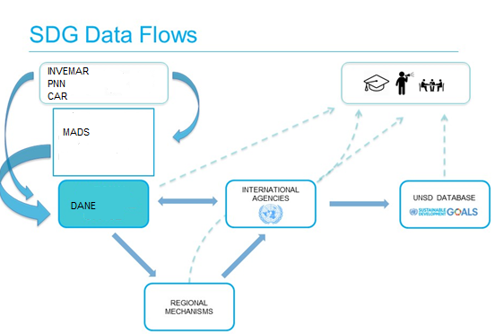

The sub-sections below provide more detail on data availability in Colombia that can feed into indicators 14.1.1, 14.2.1, and 14.5.1. The information provided below has been summarised from interviews with data-producers and from the mapping exercise that was carried out at the stakeholders meeting in Bogota.

## Indicator 14.1.1 Index of Coastal Eutrophication (ICEP) and floating plastic debris density

### Target 14.1 By 2025, prevent and significantly reduce marine pollution of all kinds, in particular from land-based activities, including marine debris and nutrient pollution

The Marine and Coastal Research Institute (INVEMAR) has a mandate to conduct basic and applied research on renewable coastal/marine resources and ecosystems. INVEMAR provides scientific advice and technical support to national entities such as the Ministry of Environment and Sustainable Development (MADS), territorial entities, and Regional Autonomous Corporations[6] (CAR) with jurisdiction in the coastlines.

INVEMAR is not currently monitoring eutrophication or floating plastic debris density. However, they have the capability to analyse remote sensing data for the country, as well as is in the process of implementing a pilot study in Ciénaga Grande de Santa Marta (coastal lagoon) to monitor Chlorophyll *a*. INVEMAR has been collecting data on different elements of marine pollution for the past 17 years that are used to report on this issue. Table 2 below was developed with INVEMAR technical personnel during the interview, and provides more detail on what type of data are available that can feed into indicator 14.1.1.

Table 2. Data collected by INVEMAR that can be fed into indicator 14.1.1 Index of Coastal Eutrophication (ICEP) and floating plastic debris density.

| **SDG** | **Element** | **Indicator** | **Type of data** | **Suitability** | **Source** | **Type of information** |
| --- | --- | --- | --- | --- | --- | --- |
|  | *Key word* |  | *e.g. on-site measurement, remote sensing data, evaluation framework* | *Cost; temporal scale, spatial scale , capacity at the national level* | *Metadata* | *Methodology (M); Data (D); Indicator (I)* |
| 14.1 | Dissolved oxygen |  | *in situ* measurement, with oxygen sensor | Feasible if the technology is available, low cost, every six months, 350 stations, INVEMAR staff through REDCAM, national level | REDCAM INVEMAR | D, M |
| 14.1 | Nitrate, nitrite, ammonium and phosphate |  | *In situ* sampling, with laboratory analysis | High cost, trained technical personnel, every six months, 350 stations, national level | REDCAM INVEMAR | D, M |
| 14.1 | Chlorophyll *a* |  | *In situ* sampling, with laboratory analysis, spectrophotometry method | High cost, trained technical staff, 32 stations in the Ciénaga Grande of Santa Marta, local level | REDCAM INVEMAR | D, M |
| 14.1 | Chlorophyll *a* |  | Remote sensing data | Medium cost, trained personnel and equipment, free images, national level | INVEMAR | D, M |
| 14.1 | Microplastics |  | *In situ* sampling, sediments of beaches, fish and water | High cost, trained personnel and equipment, 6 pilot stations, national level | INVEMAR | D, M |

INVEMAR makes all collected data available via REDCAM, which is a centralised information system for the conservation of the marine/coastal environment in Colombia. REDCAM has data on marine pollution that have been collected for over 19 years — the information feeds into a national *indicator on the Quality of Marine and Coastal Waters* (ICAM in Spanish). REDCAM also provides periodic reports on the quality of the marine and coastal waters in Colombia. INVEMAR personnel collects around 80% of data, and the Coastal Regional Autonomous Corporations collect around 20% data at the municipal level. The processes for collection and analysis of data are standardised, and INVEMAR is accredited with following ISO 17025 and ISO 9001 quality standards. All data go through quality control checks before they are made available on REDCAM.

INVEMAR does not have trend data on Chlorophyll *a*. However, they are planning to implement a pilot study at a sub-national level (in Santa Marta), and develop a roadmap for monitoring Chlorophyll *a*. Additionally, Colombia is using satellite observations from NASA[7] (MODIS-Aqua sensor), with daily temporal resolution, and spatial resolution of 1 km, as well as monthly composite images at 4 km, to estimate Chlorophyll *a* concentrations. The Chlorophyll *a* data are calibrated with samples taken *in situ* and measured in the laboratory by spectrophotometry, using the Lorenzen method. This methodology can also be used to track changes in Chlorophyll *a* in the past 15 years.

In the past, INVEMAR has collected data on marine litter following NOAA[8]’s methodology[9], and it seems that this could be easily replicated if needed. However, it was noted that INVEMAR makes use of available funding for monitoring purposes and one of the challenges of indicator development in Colombia and other countries in the region is precisely the lack of sustained available funds for monitoring purposes. Thus, it was noted that relevant data that are already collected and used for national purposes could usefully also be used to report progress on the overall SDG Target 14.1.

Figure 3 below summarises data flows from collection to communication of information for indicator 14.1.1. Its content was developed by INVEMAR and government officials from MADS, DANE, CCO and others at the stakeholders meeting in Bogota.

Figure 3. Data flows and indicator uses for indicator 14.1.1. Index of Coastal Eutrophication (ICEP) and floating plastic debris density.

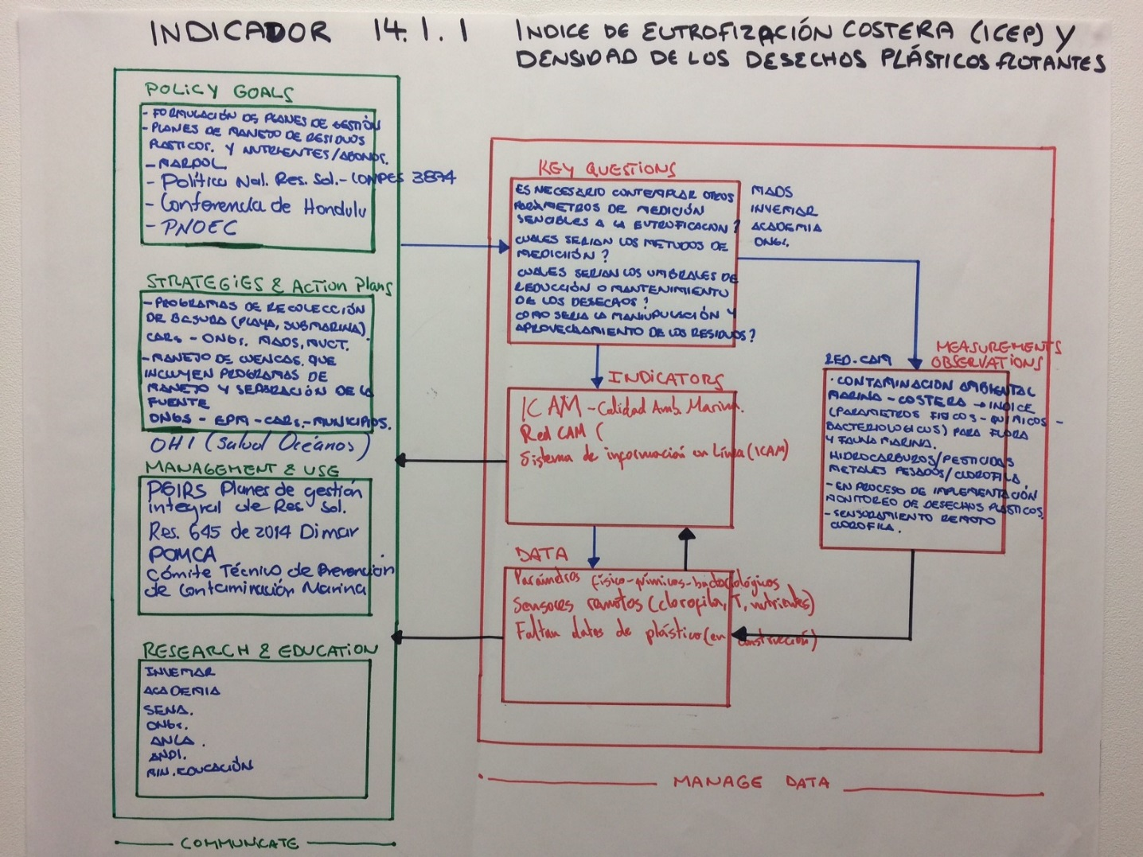

In line with the *Framework for an environmental information system* (Figure 1), it is interesting to note that MADS and INVEMAR formulate the key questions that need to be answered at the national level, which informs the type of data that INVEMAR collects on pollution (Figure 2). Although there is plenty of information available on nutrient loads, there are data gaps for e.g. Chlorophyll *a* and plastic debris. The data collected feed into the national indicator on marine water quality (ICAM). The ICAM indicator is currently used to communicate progress on policy goals, strategies and action plans at the sub-national level. A number of organisations make use of this information, for example the Technical Committee for the Prevention of Marine Pollution, the National Authority of Environmental Licences (ANLA), and research/academic institutions.

## Indicator 14.2.1 Proportion of national exclusive economic zones managed using ecosystem-based approaches

Target 14.2 By 2020, sustainably manage and protect marine and coastal ecosystems to avoid significant adverse impacts, including by strengthening their resilience, and take action for their restoration in order to achieve healthy and productive oceans

Colombia adopted the *National Environmental Policy for the Sustainable Development of Ocean Spaces, Islands and Coastal Areas* (PNAOCI)[10] to articulate the development of institutional, territorial, economic, and socio-cultural processes for the sustainable management/use of the marine and coastal environment. For this purpose, Colombia has been implementing the Integrated Coastal Zone Management (ICZM) approach and, inspired by UNESCO’s *Methodological Guide to Integrated Coastal Zone Management[11],* INVEMAR staff have developed their own national methodological guides*.* The implementation of the ICZM approach has been a collaborative effort between INVEMAR, the Corporaciones Autonomas Regionales (CAR), local actors, and other governmental and non-governmental agencies. Environmental sustainability and zoning are the basis for the implementation of ICZM in Colombia, and in some cases the ICZM processes are well aligned with local Environmental Territorial Ordinance plans (OAT).

The Colombian national indicator: *Progress in the Implementation of Planning Instruments for Marine and Coastal Zones* provides information on the existence and the state of progress on the implementation of planning instruments for the integrated management of geographically defined coastal zone areas, also known as *Coastal and Oceanic Environmental Units* (UAC and UACO in Spanish). The indicator measures the number of UAC that are making progress on the implementation of ICZM, and specifies at what stage of progress each UAC is at. The formula for the calculation of this indicator follows, along with results for the period 1999 to 2014 in Figure 4[12]:

# UAC or UACO with progress in N stage from the ICZM methodology x 100

# Total of UACO in coastal zones

Where N refers to the following stages:

1. Preparation
2. Characterization
3. Diagnostic
4. Foresight and environmental zoning
5. Guidelines
6. Formulation
7. Adoption
8. Implementation/Execution
9. Monitoring and evaluation

*Figure 4. Geographic distribution of progress in the implementation of Integrated Coastal Zone Management (ICZM) for the period 1999-2014 (source: INVEMAR 2015).*

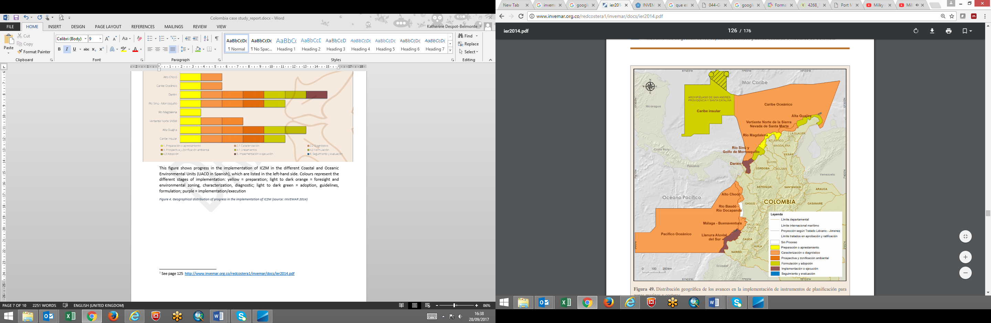

Updated information on the indicator *Progress in the Implementation of Planning Instruments for Marine and Coastal Zones* is published every year. INVEMAR staff suggested that this national indicator could be potentially adapted to include national exclusive economic zones in order to report progress on SDG Target 14.2. It was noted by INVEMAR as well as PNN staff that actual implementation of management plans and ICZM is expected to be a slow process. In terms of other elements of Target 14.2 that are currently being monitored, INVEMAR has been collecting data on mangroves and mangrove restoration for the past 15 years, and they have an indicator on the number of hectares of mangroves.[13]

Figure 5 below summarises the findings in relation to indicator 14.2.1, as developed by INVEMAR and other government entities at the stakeholders meeting in Bogota.

Figure 5. Data flow, indicator producers and users for indicator 14.2.1. Proportion of national exclusive economic zones managed using ecosystem-based approaches.

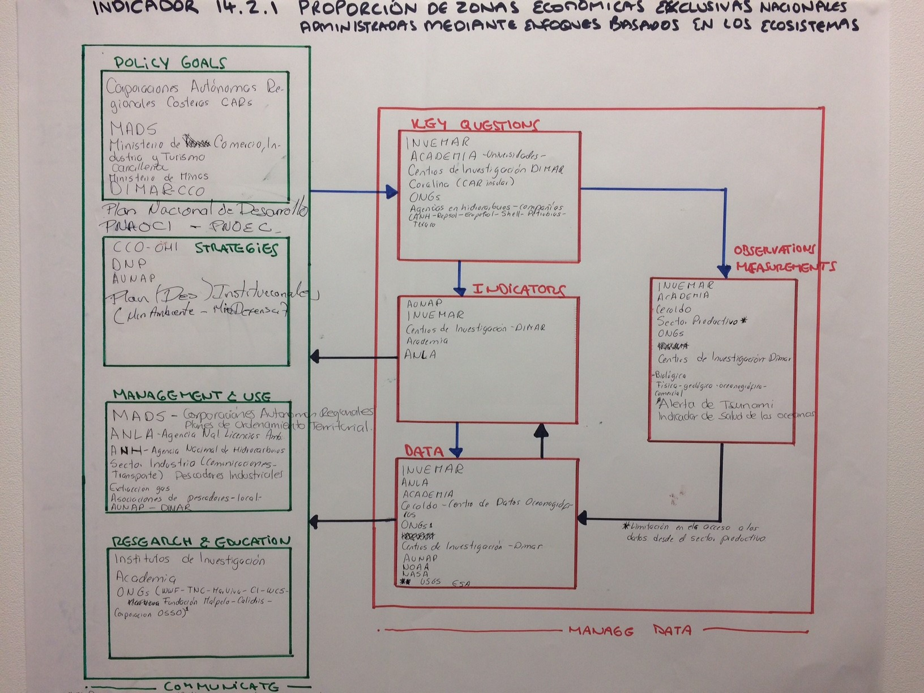

## Indicator 14.5.1 Coverage of protected areas in relation to marine areas

Target 14.5 By 2020, conserve at least 10 per cent of coastal and marine areas, consistent with national and international law and based on the best available scientific information

National Natural Parks of Colombia (PNN) is the national administrative entity in charge of coordinating the *National System of Protected Areas* (SINAP in Spanish).[14] All information related to protected area coverage is uploaded and made available on the *National Register of Protected Areas* (RUNAP in Spanish). RUNAP[15] allows the different Environmental Authorities (i.e. Ministry of Environment and Sustainable Development, Regional Autonomous Corporations, and PNN) to register protected areas under their jurisdiction and upload information into RUNAP, which is a centralised database that provide up-to-date consolidated data on protected area coverage. Colombia’s current marine protected area coverage is 13.31% of their marine/coastal territory.[16]

The information uploaded into RUNAP (<http://runap.parquesnacionales.gov.co/> ) includes metadata, geographic data (GIS polygons) and related images. PNN staff provide technical support and training to other relevant entities when required so that the information and percentages on terrestrial and marine protected areas are accurate and visualised in the form of GIS polygons.

RUNAP has an in-built validation and quality control process that ensures that all data and information (both metadata and geographical data) are accurate before this is effectively uploaded into the system. All data/information on protected area coverage is made freely available on the RUNAP website a month after a protected area has been declared. Data-users can download GIS data in shapefile format and metadata/values as PDF.

Although statistics related to protected area coverage are available via the World Database on Protected Areas (WDPA), curated by UNEP-WCMC, PNN staff can easily provide up-to-date statistics for indicator 14.5.1. At the national-level, the data/information flow for indicator 14.5.1 is as follows: MADS, PNN, CAR (upload data onto RUNAP); MADS (compiles data), DANE (reports on data).

Figure 6 below summarises the data and information flows for indicator 14.5.1, as developed by PNN, and other government entities at the stakeholders meeting in Bogota.

Figure 6. Data flow, indicator producers and users for indicator 14.5.1. Coverage of protected areas in relation to marine areas

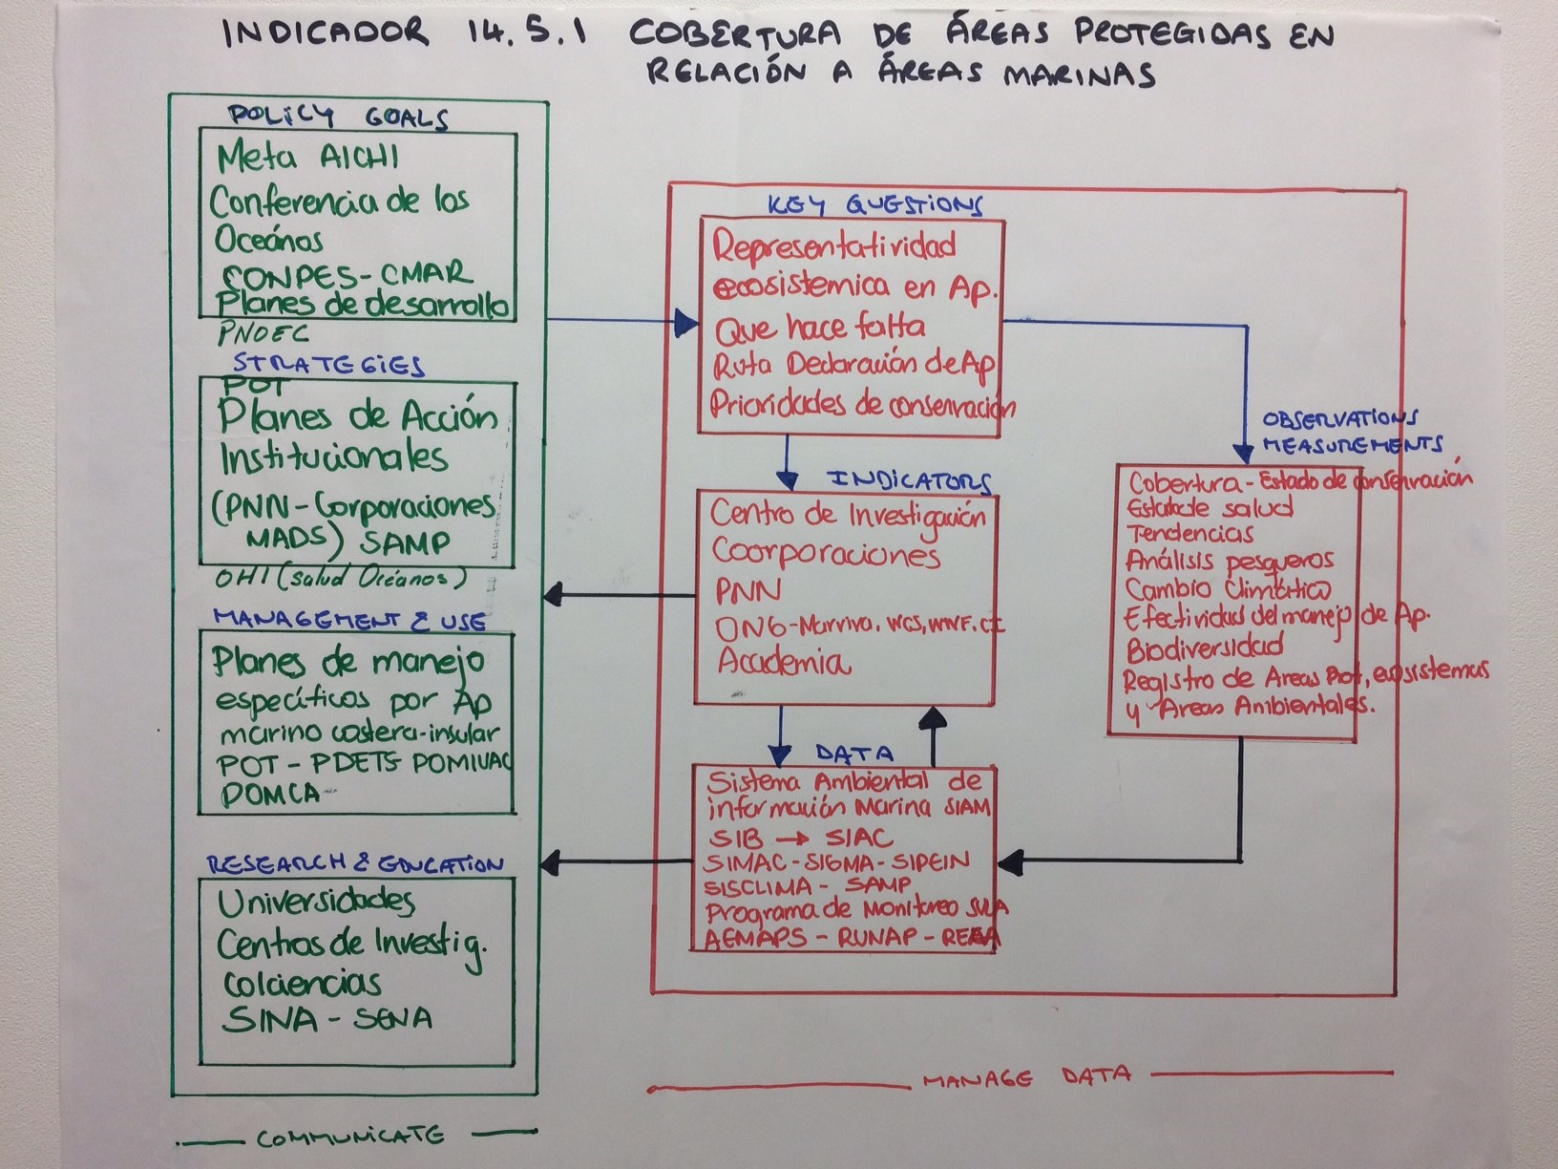

# Users of data and data-derived information at the national level

The main users of data and information from SDG 14 indicators in Colombia are the Colombian Ocean Commission (CCO), the Ministry of Environment and Sustainable Development (MADS), and the Ministry of Foreign Affairs.

The CCO is an advisory body that provides the Colombian government with policy advice on matters related to the sustainable use of the marine/coastal environment.[17] The CCO is responsible for coordinating activities across institutions towards the successful implementation of the *National Policy on Oceans and Coastal Spaces* (PNOEC)[18] 2016-2030. The PNOEC provides strategies and guidelines towards the sustainable use and conservation of the marine/coastal environment in Colombia. The CCO makes use of a number of national indicators to keep track on progress towards national targets, and they will make use of SDG 14 indicators to track progress on targets set within the *Biodiversity and Sustainable Use* theme of the PNOEC. The CCO is also looking at the possibility of developing and applying the Ocean Health Index (OHI) in Colombia, and SDG 14 indicators could potentially provide data towards specific components of a Colombian version of the OHI.[19]

MADS uses data and data-derived information from national marine/coastal indicators to inform decisions and policy in key priority areas (i.e. marine pollution, marine/coastal zoning, MPA effectiveness), to channel resources and actions where there are needed. SDG 14 indicators will provide relevant information that directly addresses their key priority areas.

Lastly, the Ministry of Foreign Affairs makes use of scientific data and derived results to provide evidence-based political messages in the international arena. For example, the Ministry of Foreign Affairs represented Colombia at the 4th Conference of Marine Protected Areas in La Serena, Chile in September 2017. The Ministry liaised with INVEMAR and PNN to promote Colombia’s current work on MPAs at the conference. In the future, the Ministry could make use of data-derived information from SDG 14 indicators when relevant and needed at international events.

# What to include on the Global Manual on Ocean Statistics

We asked interviewees to gives us their opinion on what they would expect to see in a Global Manual on Ocean Statistics. A summary of the feedback provided by data-producers and data-users in Colombia is provided below:

Data-producers would like to see:

* A compilation/summary of global methodologies, and relevant hyperlinks to resources (like a toolbox)
* Indicator factsheets with step-by-step methodologies
* Guidance of levels of confidence when choosing one method over another
* Definitions of concepts used for the different indicator elements
* Guidance on how to turn relevant data into an indicator

Data-users would expect to find:

* Guidelines on how to standardise the collection and compilations of data, like a recipe book for these three indicators.
* Recommendations on institutional arrangements for effective data flow from collection to reporting

The suggestions provided above focused on the needs of national institutions for the effective implementation of indicators for reporting progress towards SDG targets 14.

# References

CCO, 2017. *Política Nacional del Océano y de los Espacios Costeros (PNOEC)* [National Policy on the Oceans and Coastal Spaces]. [online] Available at: <http://www.cco.gov.co/docs/publicaciones/pnoec-2017-03.pdf>

INVEMAR, 2015. *Informe del Estado de los Ambientes y Recursos Marinos y Costeros de Colombia* [Report on the State of the Marine and Coastal Environments and Resources of Colombia]. [online] Available at: <http://www.invemar.org.co/redcostera1/invemar/docs/ier2014.pdf>.

Lippiatt, S, Opfer, S, and Arthur, C (2013). Marine Debris Monitoring and Assessment. NOAA Technical Memorandum NOS-OR&R-46. [online] Available at: https://marinedebris.noaa.gov/sites/default/files/Lippiatt%20et%20al%202013.pdf

MA, 2000. *Political Nacional Ambiental Para el Desarrollo Sostenible de los Espacios Oceanicos y las Zonas Costeras e Insulares de Colombia (PNAOCI)* [National Environmental Policy for the Sustainable Development of Ocean Spaces, Islands and Coastal Areas. [online] Available at: [http://www.minambiente.gov.co/images/BosquesBiodiversidadyServiciosEcosistemicos/pdf/Normativa/ /4268_161009_polit_zonas__costeras_pnaoci.pdf](http://www.minambiente.gov.co/images/BosquesBiodiversidadyServiciosEcosistemicos/pdf/Normativa/%20/4268_161009_polit_zonas__costeras_pnaoci.pdf)

Opfer, S, Arthur, C, and Lippiatt, S (2012). NOAA Marine Debris Shoreline Survey Field Guide. NOAA Marine Debris Program. [online] Available at: https://marinedebris.noaa.gov/sites/default/files/ShorelineFieldGuide2012.pdf

PND, 2014. *Plan Nacional de Desarrollo 2014-2018* [National Development Plan 2014-2018]. [online] Available at: <https://www.dnp.gov.co/Plan-Nacional-de-Desarrollo/Paginas/Que-es-el-Plan-Nacional-de-Desarrollo.aspx>

UNESCO, 2001. Steps and Tools Towards Integrated Coastal Area Management: Methodological Guide Volume II. [online] Available at: <http://unesdoc.unesco.org/images/0012/001245/124596eo.pdf>

WCS, 2017. Colombia Declares More Than 4 Million New Protected Hectares & Achieves Conservation of 13.31 Percent of Coastal Marine Area. [online] Available at: <https://newsroom.wcs.org/News-Releases/articleType/ArticleView/articleId/10509/Colombia-Declares-More-Than-4-Million-New-Protected-Hectares-Achieves-Conservation-of-1331-Percent-of-Coastal-Marine-Area.aspx>

# Annexes

## Annex 1 Colombia visit agenda

**Day 1**

*Monday 18 September (Ministerio de Ambiente y Desarrollo Sostenible – MADS)*

**Morning: Opening Session with all stakeholders**

10:00 – 10:45 Introduction: the SDGs (Sustainable Development Goals) Monitoring and Reporting Process, UN Environment role, the Global Manual on Ocean Statistics to track progress against SDG 14 (Life below water).

11:00 – 12:30 Mapping exercise: This is to identify priorities, existing/available data and indicators, and gaps. This would also serve to map out, for each indicator, data information flows and responsible/contributing institutions.

**Afternoon: Interviews**

14:00 – 16:00 Ministerio de Ambiente y Desarrollo Sostenible (MADS)

**Day 2**

*Tuesday 19 September (DANE, PNN, Cancilleria)*

**Interviews**

10:00 – 12:00 Departamento Administrativo Nacional de Estadística (DANE)

14:00 – 15:00 Parques Nacionales Naturales de Colombia

16:00 – 17:00 Ministerio de Relaciones Exteriores

**Day 3**

*Wednesday 20 September (Santa Marta)*

**Interviews**

14:00 – 16:00 Instituto de Investigaciones Marinas y Costeras (INVEMAR)

**Day 4**

*Thursday 21 September (DIMAR, Colciencias, CCO, IDEAM)*

**Interviews**

10:00 – 11:00 Dirección General Marítima (DIMAR)

11:30 – 12:30 Colciencias – National department of Science, Technology and Innovation

14:00 – 15:00 Comisión Colombiana del Océano (CCO) [This interview was rescheduled, and took place on Tuesday 10th October 2017 from 10:00-11:00 (Colombia)/16:00-17:00 (UK) via Skype]

## Annex 2 Interviewees list

|  |  |
| --- | --- |
| **Institution** | **Contact** |
| **DANE** | Diana Nova Laverde |
|  | Juan Camilo Barbosa |
|  | Carolina Cacino |
|  | Gloria Lucia Vargas Briceño |
| **INVEMAR** | Francisco Arias |
|  | Diana Isabel Gomez |
|  | Carolina Garcia |
|  | Paula Sierra |
|  | Anna Maria Gonzales Delgadillo |
|  | Constanza Ricaurte Villota |
| **CCO** | Carlos Arturo |
|  | Tania A. Romero |
|  | Johana Andrea Martinez Cuesta |
| **MADS** | Santiago Arango Botero |
|  | Diana Marcela Moreno Barco |
|  | Andres Ochoa |
|  | Oscar Fagua |
|  | Ana Maria Gonzalez |
|  | Kelly Moreno |
| **PNN** | Zoraida Jimenez |
|  | Paula Bueno Martinez |
|  | Marta Diaz |
|  | Laura Camacho |
|  | Margarita Rozo |
|  | Jorge Duarte |
|  | Nidia Mayorga |
| **Cancilleria** | Maria Claudia Vasquez |
|  | Laura Juliana Arciniegas Rojas |
|  | Sonia Angelica Jurado Caicedo |
| **UPB** | Paula Andrea Zapata Ramirez |
|  | Jackson Reina |
| **Colciencias** | Argirio De Jesus Ramirez |

Case Study Report: Assessing the availability of data and indicators in Fiji for a compilation of best practices in measuring the oceans

Contents

Acronym list 20

Introduction 21

Stakeholders meeting 21

Interviews 22

Fiji’s approach to monitoring and reporting progress on SDG 14 22

Indicator 14.1.1 Index of Coastal Eutrophication (ICEP) and floating plastic debris density 25

Indicator 14.2.1 Proportion of national exclusive economic zones managed using ecosystem-based approaches 30

Indicator 14.5.1 Coverage of protected areas in relation to marine areas 31

Users of data and data-derived information at the national level 33

What to include on the Global Manual on Ocean Statistics 34

References 36

Annexes 38

Annex 1 Fiji Case Study Visit Agenda 38

Annex 2 Fiji Case Study Visit – List of Workshop Attendees and Interviewees 40

Acronym list

|  |  |
| --- | --- |
| **Acronym** | **English name** |
| CBM | Community Based Management |
| CME | Commonwealth Marine Economies (Programme) |
| CROP | Council of Regional Organisations in the Pacific |
| MoE | Ministry of Environment (formerly Department of Environment) |
| EBSA | Ecologically or Biologically Significant Marine Area |
| EMA | Environment Management Act 2005 |
| ESIS | Environmental Spatial Information Server (SPREP) |
| FBS | Fiji Bureau of Statistics |
| FLMMA | Fiji Locally Managed Marine Areas |
| FNU | Fiji National University |
| FPO | Framework for a Pacific Oceanscape |
| FPR | Framework for Pacific Regionalisation |
| GIS | Geographic Information System |
| GIZ | Deutsche Gesellschaft für Internationale Zusammenarbeit |
| GOOS | Global Ocean Observing System (UNESCO-IOC) |
| ICEP | Index of Coastal Eutrophication) |
| ICZM | Integrated Coastal Zone Management |
| IOC | Intergovernmental Oceanographic Commission |
| IUCN | International Union for the Conservation of Nature |
| LWRM | Land, Water and Resource Management (Ministry of Agriculture) |
| MACBIO | Marine and Coastal Biodiversity Management in Pacific Island Countries |
| MEDIN | Marine Environmental Data and Information Network |
| MoF | Ministry of Fisheries |
| MPA | Marine Protected Area |
| NBSAP | National Biodiversity Strategy and Action Plan |
| NOAA | National Oceanic and Atmospheric Administration |
| PACGEO | Open access geospatial data repository for the Pacific Region providing premier geophysical, geodetic, and marine spatial data sets |
| PCCOS | Pacific Community Center for Ocean Science |
| PEIN | Pacific Environment Information Network (SPREP) |
| PIFS | Pacific Islands Forum Secretariat |
| PIROP | Pacific Islands Regional Ocean Policy |
| PRSD | Pacific Roadmap for Sustainable Development |
| PSSC | Pacific Statistics Steering Committee (supports Pacific SDG Taskforce) |
| PST | Pacific SDGs Taskforce |
| SDG | Sustainable Development Goals |
| SPC | Pacific Community |
| SPREP | Secretariat of the Pacific Regional Environment Programme |
| SPTO | South Pacific Tourism Organisation |
| UNEP | United Nations Environment Programme |
| UNEP-ROAP | United Nations Environment Programme - Regional Office for Asia and the Pacific |
| UNEP-WCMC | United Nations Environment Programme – World Conservation Monitoring Centre |
| UNESCAP | United Nations Economic and Social Commission for Asia and the Pacific |
| UNESCO | United Nations Educational, Scientific and Cultural Organization |
| USP | University of the South Pacific |
| WCS | Wildlife Conservation Society |
| WDPA | World Database on Protected Areas |
| WWF | World Wild Fund for Nature |

Introduction

This report presents details from a country visit to Fiji, the aim of which was to assess the availability of and requirements for data and indicators to assist in production of best practices guidelines that will help to enable countries to develop methodologies to track progress towards Sustainable Development Goal (SDG) 14, “Life below water”. Two case studies, this one from Fiji and a second from Colombia, provide practical, national-level details used to inform the development of the Global Manual on Ocean Statistics.

The three-day visit took place from November 1st through 3rd 2017 in Suva, Fiji, and included an initial joint stakeholders meeting followed by individual interviews with the same relevant - and a few other - institutions (see agenda, Annex 1). The mission was led by Elisabetta Bonotto from United Nations Environment (UN Environment) and Fiona Danks from UN Environment World Conservation Monitoring Centre (UNEP-WCMC), with support from and Katherine Despot-Belmonte (also UNEP-WCMC).

The purpose of the case-study visit was, through in-person flow-mapping exercises and interviews , to gather best practice details with regards to data flows, indicators, and methodologies for data collection and indicator calculation within Fiji, for each of three focal, global indicators. UN Environment is the custodian agency for SDG indicators 14.1.1. *Index of Coastal Eutrophication (ICEP) and floating plastic debris density*, 14.2.1 *Proportion of national exclusive economic zones managed using ecosystem-based approaches*, and 14.5.1 *Coverage of protected areas in relation to marine areas*. The visit provided additional opportunity to assess and validate the suitability of the step-by-step methodologies that are being developed as part of the Global Manual on Ocean Statistics.

Stakeholders meeting

The initial stakeholders workshop took place in the Fiji Bureau of Statistics (FBS), an office of the national government, in downtown Suva, Fiji, and indeed the mission was supported by the Bureau throughout. The meeting was convened by Epeli Waqavonovono and Litia Kurisaqila (FBS), along with Elisabetta Bonotto and Fiona Danks. Fourteen participants attended the meeting, representing both data producers and data users (and sometimes both) from relevant national government institutions (such as the Ministry of Environment MoE, Ministry of Fisheries MoF, and the Bureau of Statistics), national and regional universities and institutes (such as the University of the South Pacific USP), regional organisations and institutions (such as Secretariat of the Pacific Regional Environment Programme SPREP, and the Pacific Community SPC), and non-governmental organisations (NGOs) (such as the World Wild Fund for Nature WWF). A full list of workshop and interview participants can be found in Annex 2. Please note that some representatives attended both components, and others one of either the workshop or interview. We interviewed a total of eleven organisations.

The workshop began with a formal welcome by Epeli Waqavonovono and then a round of introductions of all of the participants and convenors. This was followed by presentations from Elisabetta Bonotto and Fiona Danks that provided background on the SDG monitoring and reporting process, the role of UN Environment as custodian agency, the project and project aims, the Global Manual on Ocean Statistics and the role of Fiji as a case study, and details on the objectives of the three-day visit.

The second part of the meeting, led by UNEP-WCMC, was interactive and focused on a flow-mapping exercise with all stakeholders to contribute details on data flows from collection to analysis to policy input for SDG 14 indicators 14.1.1, 14.2.1, and 14.5.1. Participants were provided with blank diagrams of the *Framework for an environmental information system for National Biodiversity Strategies and Action Plan (NBSAP) implementation and SDG achievement* (Figure 1). The outcomes of the mapping exercise are shown in later sections in Figures 3, 4, and 5 of this report.



*Figure 1: Framework for an environmental information system for NBSAP implementation & SDG achievement (UNEP-WCMC, 2016).*

Interviews

The second part of the first day and the two subsequent days were taken up with interviews with all of the available, relevant stakeholders, both with data/indicator producers and users. Each interview lasted between one to two hours generally and followed a specific set of questions in most cases, adapted according to relevance of the interviewees. Interviews with data producers helped to identify which indicators and methodologies (including targets and thresholds) Fiji is currently considering or implementing, which institutions are involved in the production of data, why certain approaches were chosen or not, what is working well and what the limitations and challenges for indicator development are. The interviews with data users helped to identify what data exist and what data are needed, what the data and indicator gaps may be, and who will make use of data and indicators for reporting or other purposes.

Overall, the targeted, detailed interviews along with discussions in and outputs from the stakeholder meeting helped to document the indicator cycle from data collection to reporting to policy inclusion, assessing the current capacity for indicator development in Fiji, identifying any existing mandates and the relevant institutions involved and their roles in the processes.

Fiji’s approach to monitoring and reporting progress on SDG 14

Monitoring and reporting on Fiji’s progress towards SDG 14 is the responsibility of the Ministry of the Environment, together with the Ministry of Fisheries and the Bureau of Statistics. While various government institutions are involved in this process, they do not necessarily have a clear mandate at this point in time to work on feeding into SDG indicators or to compile information that can be used to report progress on SDG Targets 14.1, 14.2, and 14.5. There may be opportunity for their roles to be further differentiated and clarified additionally.

The data/information flows from collection to reporting of marine related information are in general known but less clearly determined for SDG 14 in particular, possibly in part because reporting processes may not yet be fully developed. The responsible national government institutions are, however, meant to liaise with the Pacific Statistics Steering Committee (PSSC) which supports the Pacific SDG Taskforce and which is tasked with developing an annual balance on progress towards targets. No specific outputs to be shared with, for example the UN High Level Political Forum, were mentioned during the course of the visit, but such products may well exist. On a national and regional level, the key organisations involved in data flow are the Pacific Community, a regional International Governmental Organisation (IGO) that supports Fiji and has responsibility for data, SPREP (Secretariat of the Pacific Regional Environment Programme) and potentially PACGEO[20], an open access geospatial data repository for the Pacific Region providing premier geophysical, geodetic, and marine spatial data sets. Academic institutions like USP (University of the South Pacific) also play a role but their data may be more difficult to access. The Marine and Coastal Biodiversity Management in Pacific Island Countries (MACBIO) Project, with its support to Fiji in marine spatial data compilation, also plays a relevant role, with data flow mainly to the Ministry of Environment and Ministry of Fisheries (as well as to regional repositories like PACGEO and SPREP Pacific Environment Information Network PEIN).

It is relevant to detail that Fiji’s Fifth National Report to the United Nations Convention on Biological Diversity (Department of Environment, 2014) aimed, in part, to assess progress towards the Aichi Biodiversity Targets and the Millennium Development Goals, and in particular, it assessed in detail alignment between Fiji’s National Targets with the Aichi Targets (pg. 57-79). A dedicated, similar assessment could be done with the SDGs, and for this case study, with SDG 14. Such effort might elucidate specific roles that national government branches and other organisations could play in addressing particular targets. Additional relevant information is contained in the Report, such as details on Fiji’s National Biodiversity Strategy and Action Plan.

It is important to note, in the case of Fiji and other Pacific Island states, the valuable role of regional institutions such as the Council of Regional Organization of Parties (CROP) agencies, i.e., SPREP and the Pacific Community, in these data flow, including via technical support, and policy processes. Given the similar nature of many of the Pacific Island states (i.e., primarily marine territory, the critical importance of marine resources, etc.), and of the wider region in general, a number of regional organisations, bodies, policies and frameworks exist that provide coordination and support to the countries of the region. These organisations can provide (and use) relevant, broader-based data, indicator assessment and policy input, on both a national and regional level. In the case of the Pacific Island states, these regional institutions play an important role in many stages of the process from data production and analysis to reporting and policy implementation, and in providing extra capacity.

The Pacific Islands Regional Ocean Policy (PIROP) connects strongly to SDG 14 with its prioritisation of information needs and strengthening capacity, and the Framework for a Pacific Oceanscape (FPO) is also relevant, with its focus on sustainable development, ocean management and more targeted use of knowledge. Aligning components of the PIROP and FPO with other national and regional approaches such as the Framework for Pacific Regionalisation (FPR) would further benefit ocean management and governance.

In preparation for the March 2017 Pacific Regional Preparatory Meeting for the UN Ocean Conference, a document was prepared that aimed to provide clear regional context, emphasize the importance of building on policies and agreements to support regional and national achievement of SDG targets and highlight the importance of biodiversity conservation and marine management (PRPM-UNOC, 2017). Within these higher level approaches, more focussed policies exist that target even more specifically SDG 14, e.g., the Future of Fisheries Roadmap and the New Song for Coastal Fisheries (Secretariat of the Pacific Community, 2015).

It is important to note that United Nations Economic and Social Commission for Asia and the Pacific (UNESCAP), through its relevant mandates, supports the Global Manual on Ocean Statistics and, in particular, Fiji-specific assessment, and is able to follow up on efforts to support coverage of SDG indicators – UNESCAP has a complementary agenda. The resolution, "*Strengthening Asia Pacific's support for the United Nations Conference to Support Implementation of Sustainable Development Goal 14*" (adopted at the 73rd Session of the Economic and Social Commission for Asia and the Pacific), requests the ESCAP Secretariat to ‘*continue to support current regional partnerships and develop new regional partnerships, where appropriate, for enhancing data and statistical capacities for Goal 14*’. This resolution is complements one adopted at the 72nd Session on "*Regional cooperation to promote the conservation and sustainable use of the oceans, seas and marine resources for sustainable development in Asia and the Pacific*" for which the ESCAP Secretariat should assess capacity development needs for the implementation of SDG 14. As such, ESCAP is planning national case studies to address requirements for technical guidance on how to address capacity development needs and strengthen data and statistics in support of SDG 14 with two components:

1. Capacity development needs assessment for implementing SDG 14: a review of national ocean governance mechanisms, including gaps and best practices, policy frameworks, institutional, financial, socio-cultural and other barriers, stakeholders and existing initiatives, as well as good practices and lessons learned to respond to SDG 14.
2. Integration of existing statistics conceptually and spatially along SDG 14-related priorities, through measurement guidelines on a feasible set of core statistics and training modules linked to the System of Environmental-Economic Accounting (SEEA).

Figure 2 below illustrates the data flows on the governance and policy levels, tailored to Fiji, from collection to reporting of data for SDG Targets 14.1, 14.2, and 14.5. The following additional details expand the details in the figure and from above: International agencies – UN Environment (including the Regional Office for Asia and the Pacific ROAP), UNESCAP, GOOS (UNESCO-IOC)[21]; Regional mechanisms – CROP (Council of Regional Organisations in the Pacific) Agencies (including the Pacific Islands Forum Secretariat PIFS), the Framework for Pacific Regionalisation (FPR), Commonwealth Marine Economies (CME) Programme, PIROP, Pacific Roadmap for Sustainable Development (PRSD), Framework for a Pacific Oceanscape (FPO), MACBIO[22], the Marine Sector Working Group, Cleaner Pacific 2025; and Communication/dissemination/education mechanisms. Please note that the Ministry of Agriculture is specifically relevant through the Land, Water and Resource Management (LWRM) branch.

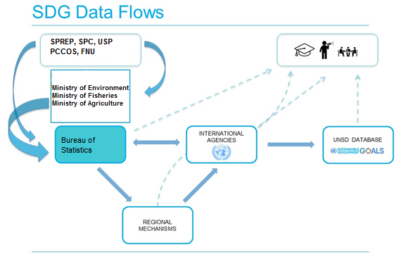

*Figure 2. Data flows from collection to reporting in Fiji for Sustainable Development Goal (SDG) Targets 14.1, 14.2, 14.5.*

The sub-sections below provide more detail on data availability in Fiji that can feed specifically into indicators 14.1.1, 14.2.1, and 14.5.1. The information provided below has been summarised from interviews with data-producers and from the flow-mapping exercise that was carried out at the stakeholders’ workshop on Day 1 of the country visit.

Indicator 14.1.1 Index of Coastal Eutrophication (ICEP) and floating plastic debris density

Target 14.1 By 2025, prevent and significantly reduce marine pollution of all kinds, in particular from land-based activities, including marine debris and nutrient pollution

Currently, no national programme in Fiji exists for monitoring eutrophication or floating plastic debris density at a national level, and there is not a mandate nor universal framework. During the country mission, the general consensus from government participants and NGOs alike was that a lack of coordination, the administration of different targets by different organisations, coupled with the complexity of SDG reporting, make monitoring and reporting a challenge in Fiji. The geographic nature of the country, comprising over 300 islands with substantial coastline and most of its area marine and spread out, makes these additionally challenging tasks, being true across all three indicators considered.

However, localised activity and site-specific measurements take place at the national level by the University of the South Pacific as part of its research projects, including by students. Notable regional involvement includes effort from the Pacific Community (USP) and SPREP’s Waste Management and Pollution Control Team, and additionally via the Cleaner Pacific 2025 strategy.

Specifically, USP has some but limited data on oil pollution, Persistent Organic Pollutants (POPs), metals, sewage, sedimentation, runoff and possibly data on fertilisers. In terms of microplastics, USP additionally has some surface water measurements, sediment measurements, aquatic organisms and off-shore samples. A number of organised beach clean-ups occur, also, but in general, data are not collected from these activities, and they may be a result of local efforts rather than institutionally regulated processes. National-level NGOs and government ministries may have additional, but again localised, data.

Table 1 below was developed with various organisations interviewed and provides more detail on the type and availability of data that are currently being collected, or that have the potential to be collected or produced. Fiji has potential for more data collection and analysis, but such effort would require coordination by key national and regional organisations.

*Table 1. Description of the current state and/or best practices in Fiji for developing indicator 14.1.1, along with other elements of Target 14.1.*

| **SDG Target** | **Element** | **Indicator** | **Dataset type** | **Suitability** | **Information type** |
| --- | --- | --- | --- | --- | --- |
|  | *To be used as basis for defining key words for searches* |  | *e.g. in situ measurement, remote sensing data, assessment framework* | *Cost; temporal scale; spatial scale; country-level capacity* | *Methodology (M); Dataset (D); Indicator (I)* |
| 14.1 | *Chlorophyll a* |  | *In situ* | Data not currently available but resources exist to set up | M, D |
| 14.1 | *Chlorophyll a* |  | Remote sensing | Satellite remote sensing data from the moderate resolution imaging spectroradiometer (MODIS) instrument (Terra and Aqua satellites) is used to estimate daily average photosynthetically available radiation at the ocean surface. For ocean colour applications, photosynthetically available radiation is a common input used in modelling marine primary productivity.  By measuring what kind of light is absorbed and reflected, the MODIS sensor aboard NASA's Aqua satellite can measure chlorophyll concentrations in the ocean (http://pifsc-oceanwatch.irc.noaa.gov/erddap/griddap/OceanWatch_aqua_chla_monthly.graph and http://oceancolor.gsfc.nasa.gov/cms/)  Data are not currently assessed in Fiji but the possibility exists, however, suitability of the resolution for small islands must be considered. | D |
| 14.1 | *Dissolved oxygen* |  | *In-situ* | Possibility exists to develop data collection for this at USP but a programme does not currently exist  Data may be available from Bio-ORACLE database, a series of 23 geophysical, biotic and climate data layers which have been compiled from global satellite and in situ measured data representing various aspects of the marine environment relevant and assembled at a resolution of 5 arcmin (ca.9.2km) http://www.oracle.ugent.be/ | M |
| 14.1 | *Nitrite/*  *Fertiliser* |  | *In situ* | Limited, localised data exist in Fiji  Data potentially available from Bio-ORACLE database (see above): http://www.oracle.ugent.be/ | D |
| 14.1 | *Faecal coliform* |  | *In situ* | Data available from USP student projects and other effort but not at national level https://www.usp.ac.fj/index.php?id=18190  Microbiology lab facilities not available limiting analysis potential; USP has a suitable chemistry lab and potential for PCB, DDT, and metals analysis if equipment available (currently malfunctioning) | M,D |
| 14.1 | *Nutrients* |  | *In situ* | Limited spatial data exist (for Fiji’s marine planning) supported by the MACBIO Project.  USP may have isolated additional data. Equipment potentially exists for use at USP but investment is required.  Phosphate and nitrate available from Bio-ORACLE database http://www.oracle.ugent.be/ | M,D |
| 14.1 | *Micro-plastics* |  | *In situ* | Some data available on surface water, sediments, organisms, off-shore surface water – detection of fibres and particles  Some regional data available (microplastic concentration (grams/km2)) | M,D |
|  | Pollution (PAHs, metals, Microplastics) |  | *In situ* | USP School of Marine Studies collected data along the Viti Levu Coast every 3 months between August 2015-2017.  USP has a suitable chemistry lab and potential for PCB, DDT, and metals analysis if equipment available/functional. | D |
| 14.2 | *Seagrass extent* |  | *In situ* (Remote sensing potential) | Data do not exist at national scale, only in local sites; Fiji-wide distribution not known - significant ecosystems exist where extent is unknown and management is not established  But a seagrass assessment for Fiji has been published: http://www.tandfonline.com/doi/pdf/10.1080/00288330.2006.9517426  See also McKenzie and Yoshida (2007) and http://www.seagrasswatch.org/Info_centre/Publications/pdf/Seagrasses_of_the_Fiji_Islands_2007.pdf  Regional Seagrass data are available: UNEP-WCMC Seagrass Richness (e.g., 2003, 2005) | D |
| 14.2 | *Mangroves* |  | *In situ* (Remote sensing potential) | Distribution known to an extent and in parts but not national coverage, e.g., IUCN may have some data through the MESCAL project; some degree of management exists; mangroves are protected to a varying degree by some level of policy support, a draft management plan, etc. but licenses for development can lead to mangrove removal  MoE holds spatial mangrove data  On a regional level data from the Regional Mangrove Forest Biomass 2014 (http://dx.doi.org/10.1111/conl.12060) and the  Regional Atlas of Mangroves, 2011 UNEP-WCMC, exist. | D |

A centralised information system for data on the conservation of the marine and coastal environment in Fiji does not currently exist although data exist in various locations and formats. Further issues, caused in part by the absence of centralisation, are a lack of data sharing and data archiving. Some national data are, however, contained in two regional portals, the first in SPC (http://www.pacgeo.org) and the second in SPREP’s Environmental Spatial Information Server (ESIS) (http://gis.sprep.org/). Addressing these challenges is highly important to enable progress on critical environmental issues.

In general, data are collected by data producing organisations such as SPC and academic institutions such as Fiji National University (FNU) and USP. Other regional and international organisations such as SPREP, International Union for the Conservation of Nature (IUCN) and GIZ (a German development agency), through the MACBIO project, support Fiji in data compilation and gathering for specific data sources; they currently have collected over 100 datasets and data layers (for use in GIS) including biological and fisheries data (fish, coral reef, seagrass, mangroves extent), biophysical and bathymetry data, and watershed assessment data (from the Wildlife Conservation Society WCS). These compiled data are connected to individual communication products and knowledge platforms, and assist in addressing national obligations, e.g. tracking progress against Aichi Targets of the UN Strategic Plan for Biodiversity. Additionally, PACGEO, may have relevant geophysical and marine spatial datasets. Research on relevant processes such as sea-level rise and ocean acidification are of potential value too, as these data may inform assessments against Target 14.1. Additionally, various potentially relevant short- and long-term fisheries commitments in the Ocean Portal for SDG 14 exist, and there is a national management plan for protecting fish stocks across coral reefs in Fiji that aims to be implemented by June 2018 (*pers. comm.*, Ministry of Fisheries).

Currently, the consensus is that not enough data exist for the production of indicators, and baseline information is still very much needed. Also of note, quality assurance and data standards vary, potentially limiting data utility. It would be useful to know if any more widely-based studies or coordinated processes are planned for the future, either for eutrophication or marine litter. Organisations supported the idea of eutrophication data being possible to obtain from new sources. There is good potential for the use of remote sensing to provide Chlorophyll *a* data; the possibility exists for such effort to be much larger in scale, regional or even wider, aiding the likelihood of data provision if issues of cost can be overcome. Regarding marine litter, the National Oceanic and Atmospheric Administration (NOAA) in the United States has developed a methodology which is being replicated in Colombia as part of its attempts to address SDG 14; in Fiji, microplastics are extracted using NOAA’s methodology for marine samples. It might be possible for Fiji to consider a broader approach of employing existing methodologies if national efforts are not yet underway. It was clear that the various organisations felt data towards supporting 14.1.1 were important, also for Fiji to understand the state of environment, and efforts to enable this would likely be supported.

As with many other countries and regions of the globe, one of the primary challenges of indicator development in Fiji and the Pacific region is the lack of available funds for large-scale data collection and monitoring purposes. Additionally, as stated previously, Fiji’s ocean-based (98% of its territory is marine), multi-island make-up and associated characteristics make data collection efforts more logistically complicated, more expansive in geographic spread and more expensive. From discussion with the Ministry of Fisheries and others, it was apparent that mechanisms to address data collection and quality, collation and storage would be welcomed. For example, there have been efforts to set up an inshore fisheries management division with establishment of responsibility for data and duties, access and web-based information, along with the funding of two technical positions within government. In addition, the first Regional Technical Meeting on Coastal Fisheries (RTMCF) has just been held in Noumea (November 28 to December 1, 2017), addressing related issues as agreed at the Tenth Heads of Fisheries Meeting held in Noumea in March 2017. This process links back to the New Song (SPC, 2015) and should assist with providing much needed information for reporting to leaders under the annual Coastal Fisheries Report Card (*pers. comm.*, Cherie Morris) - the overarching theme is to address data shortages in coastal fisheries in support of better resource management. The Forum Leaders have also tasked the SPC to coordinate with National Fisheries Agencies, CROP agencies and regional and national community groups, to strengthen support and resourcing for coastal fisheries management. Better data will allow countries to report against the indicators under Sustainable Development Goal 14.

Of note is that the Pacific SDGs Taskforce (PST), which is developing a Pacific SDGs Roadmap to guide regional efforts, in conjunction with the Pacific Statistics Steering Committee (PSSC), had identified an initial set of 109 SDG indicators for the Pacific. Of the ten global SDG 14 indicators, seven have been selected for the Pacific, though indicator 14.1.1 was not (PRPM-UNOC, 2017). The exact impact of this on Fiji’s reporting for this indicator and associated target is unclear. It does appear that regional level processes, which may have more capacity than national level ones, do exert a large influence in the Pacific Island States and so this must be considered when examining Fiji’s case.

Clear interest and understanding exist in Fiji, so hopefully additional frameworks and mechanisms for improved data collection and flow for indicator production can be developed in the future. The general view is that a step-by-step approach, such as that to be provided by the developing Global Manual on Ocean Statistics, is a good and viable approach, with relevance to Fiji, particularly considering its current limited capacity. Finally, the provision of a framework and an otherwise absent link to the reporting framework are seen to be of real value.

Figure 3, filled in as part of the workshop activities, summarises data flows from collection to communication of information for indicator 14.1.1. The content was developed by stakeholders and government officials from relevant organisations at the stakeholders meeting in Suva, Fiji on Day 1 of the case study visit. It shows that a variety of national and international policies provides relevance to data for Target 14.1 and its indicators. National policies include the Environment Management Act 2005 (EMA) and relevant national/regional projects come from SPREP and SPC.

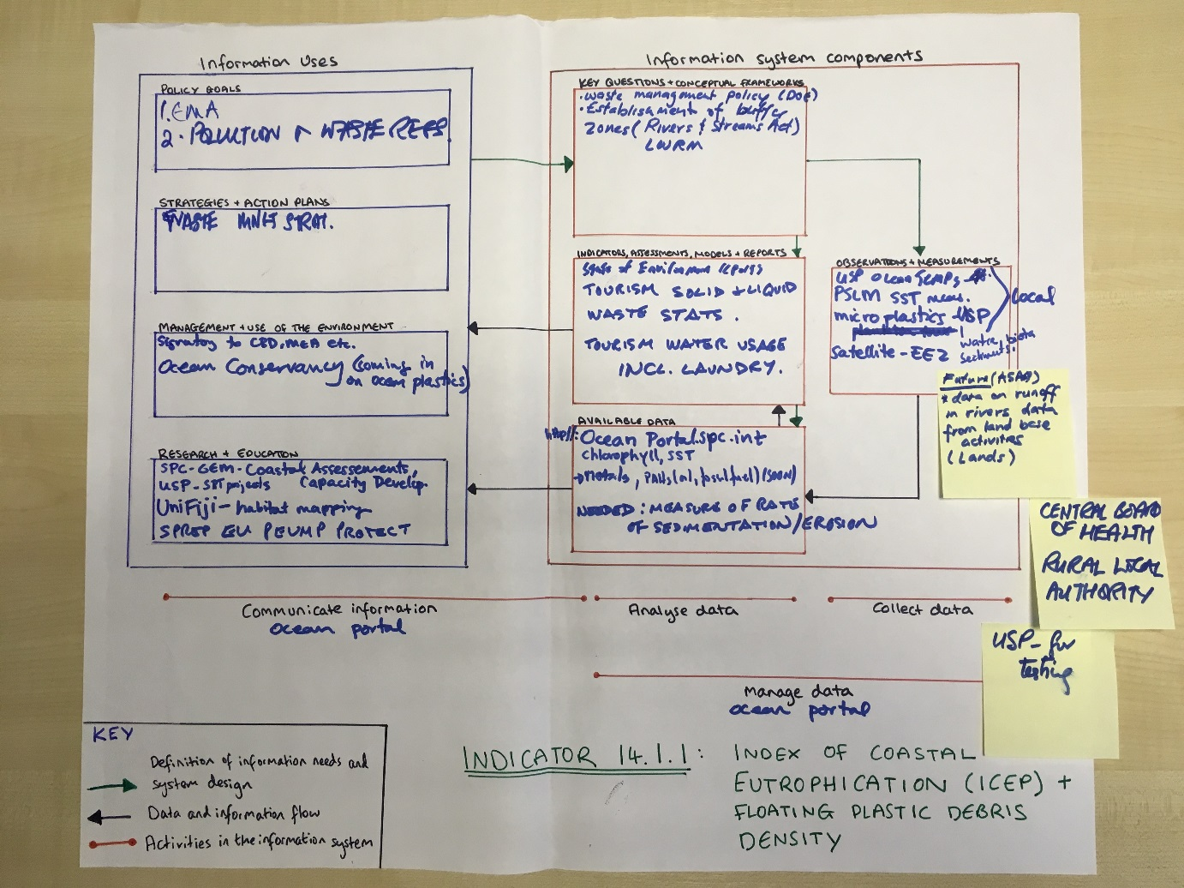

*Figure 3. Data flows and indicator uses for Fiji for indicator 14.1.1. Index of Coastal Eutrophication (ICEP) and floating plastic debris density.*

Indicator 14.2.1 Proportion of national exclusive economic zones managed using ecosystem-based approaches

Target 14.2 By 2020, sustainably manage and protect marine and coastal ecosystems to avoid significant adverse impacts, including by strengthening their resilience, and take action for their restoration in order to achieve healthy and productive oceans

Currently in Fiji there seems to be limited development of institutional, territorial, economic, and socio-cultural processes for the sustainable management/use of the marine and coastal environment. It was not apparent that clear plans currently exist for implementation of indicator 14.2.1, based on the information gained from the organisations interviewed. This target and indicator are seen as ambitious for Fiji given that a framework is not yet in place at the national-level. Hence, sufficient data may not yet exist and, from a national perspective, regional bodies may have greater influence or capacity. The Pacific Islands Forum Secretariat (PIFS), an IGO organisation which represents the Forum Leaders, is relevant here for its support of the CROP agencies such as USP, SPREP, SPC, and the South Pacific Tourism Organisation (SPTO), which have valuable influence and a high level of capacity. One more challenge in addition to data availability is a potential lack of explicit understanding as to what is expected for this indicator and how Fiji is meant to approach its role in contributing to assessment of this target.

In terms of processes in existence or in development to implement indicator 14.2.1 or even considering the wider target, again, similar to indicator 14.1.1, various localised and piecemeal projects and information exist, and there are working groups in existence but their role was not mentioned/understood by all organisations consulted. Fiji is committed to an EEZ[23]-wide planning approach, supported by MACBIO and other organisations which assist in compiling spatial data of relevance. FLMMA (Fiji Locally Managed Marine Areas) is taking an ecosystem based approach in its assessment so some key approaches are being applied. The Pacific Community (SPC) is of the opinion that a national approach is possible, considering for example mangrove coverage: some current data exist, old data in the form of topographic maps exist, and there is a possibility to combine information. Discussion was also had on Marine Spatial Planning (MSP) (in line with standards and in agreement with the UN Convention on Laws of the Sea (UNCOLS) protocol) and how efforts with this could help establishment of Marine Protected Areas (MPAs) and additionally relate to 14.2.1. A substantial project by SPC is underway to ensure accurate establishment of sea and marine boundaries.

In terms of other elements of Target 14.2 that are currently being monitored, as mentioned above, mangrove data do exist in various spatial and temporal forms but no clear related indicator yet exists. It is relevant to note, however, that some overlap exists with Target 14.5, in particular when considering the situation of marine management and protection in Fiji as it may not always be explicit whether conservation effort is for management or for protection and, therefore, there is a degree of potential overlap. This lack of clarity also presents a challenge, however.

Again, the step-by-step approach of the developing Global Manual on Ocean Statistics is seen as appropriate and valid to help Fiji in this indicator process. Another possibility for Fiji might be to consider the approach of Colombia who have developed a tailored Integrated Coastal Zone Management (ICZM) approach with their own methodologies based on UNESCO’s Methodological Guide to Integrated Coastal Zone Management. The flexibility that this seems to allow would provide Fiji to create a best-fit mechanism within an existing overarching approach and to begin to fill in any gaps in the creation of indicators.

Figure 4 summarises the information provided by organisations and government agencies at the flow-mapping component of the stakeholders meeting in Suva, Fiji on Day 1 of the case study visit.

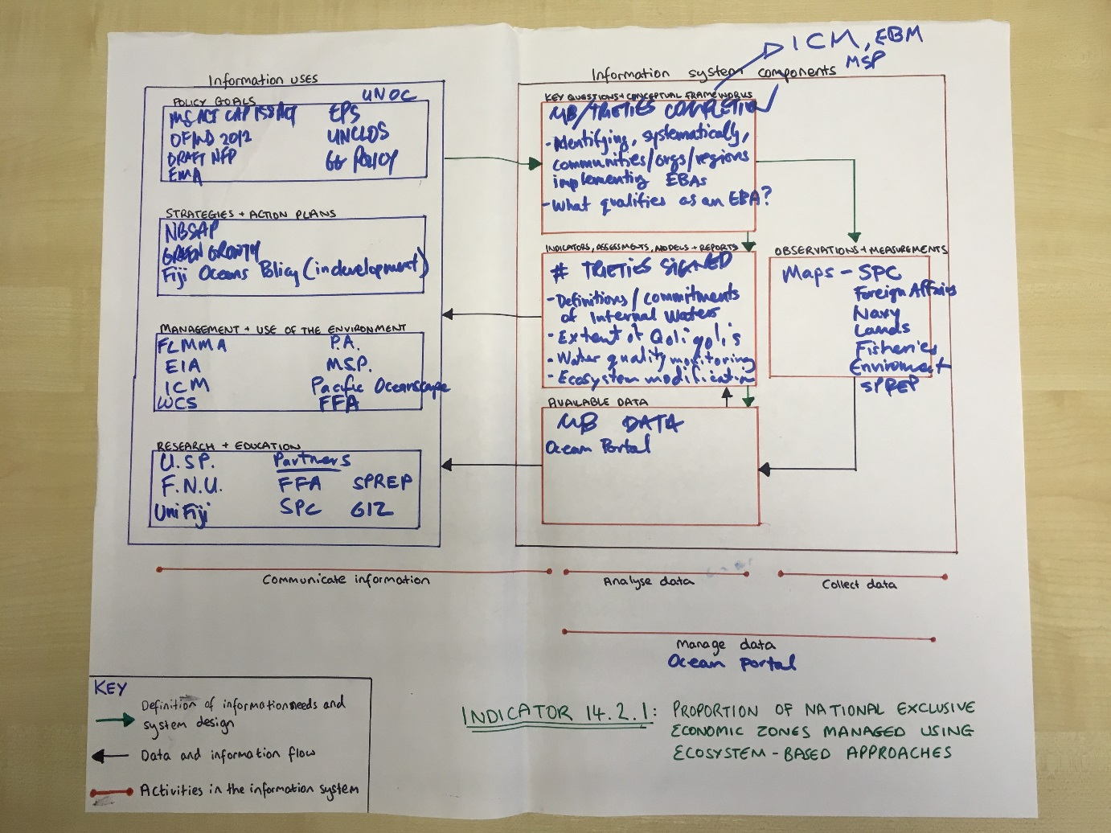

*Figure 4. Data flow, indicator producers and users for Fiji for indicator 14.2.1. Proportion of national exclusive economic zones managed using ecosystem-based approaches.*

Indicator 14.5.1 Coverage of protected areas in relation to marine areas

Target 14.5 By 2020, conserve at least 10 per cent of coastal and marine areas, consistent with national and international law and based on the best available scientific information

Fiji Locally Managed Marine Areas (FLMMA) is a national, non-profit association that comprises conservation NGOs, government departments, academic institutions and over 400 communities working together to promote and encourage the preservation, protection and sustainable use of marine resources in Fiji (http://lmmanetwork.org/who-we-are/country-networks/fiji). FLMMA has a focus on MPAs in Fiji efforts have resulted in 135 of Fiji’s customary fishing areas (*iQoliqolis*) being managed and the existence of about 465 fishing reserves (*tabu*) covering just over 1,000 km2. Current effort is focusing on prioritising national areas in Fiji, with the application of specific criteria to identify areas that should be protected or effectively managed. Efforts in the greater Pacific region have focused on trying to assess the value of marine areas, rather than just setting aside areas (SCBD, 2014).

Fiji’s current marine protected area coverage, according to SDG definitions, is approximately 1% of the total marine/coastal zones (some estimates are slightly above and some slightly below), with Protected Planet estimating 0.92% coverage across 137 separate MPAs (11,953 km2 of a total 1,293,035 km2 protected) (https://protectedplanet.net/country/FJI; http://www.mpatlas.org/region/nation/FJI/). Information on Fiji’s protected area coverage is available through the World Database on Protected Areas (WDPA). All data are listed as coming from the National Trust of Fiji, whom were not available for the workshop nor interview during the site visit, unfortunately. FLMMA, SPREP (particularly in the future) and possibly the Ministry of Environment in addition may all contribute to providing information and, therefore, to report progress towards indicator 14.5.1. Whilst the WDPA has made substantial effort to improve its country databases, with a focus in Fiji in 2015, this process is an ongoing one. The WDPA aims to ensure a level of quality assurance and data consistency, within and across regions and the globe.

A Community Based Management (CBM) system is in place in Fiji and serves to protect critical marine zones. For instance in the 1980s and 1990s, commercial fishing pressure posed a serious threat to Namena’s reefs and, in response, chiefs responded by placing a total ban on fishing through the creation of the Namena MPA in 1997 (http://www.namena.org). Of relevance again is the issue of differentiation between the terms managed and protected, especially since although local areas have traditionally been protected, management criteria may not have been the same as that for meeting international mandates. Of further relevance to the Fiji case is that land ownership and rights are connected to Fijians and Fijian communities and a degree of sensitivity can exist; as marine areas are locally managed, there is a question surrounding ownership of data and information on these areas – some concern exists over the publicising of data lest it be used for other intentions or purposes. This has relevance to the completeness of the data for Fiji that are in the WDPA. Finally, of note is MSP related effort for its potential relevance to MPA development (as noted above under 14.2.1).

On a regional level, the Office of the Pacific Ocean Commissioner (OPOC) is relevant to 14.5.1 (and beyond) through its coordination of the Pacific Ocean Alliance (POA), a network of public, private sector, NGO and other organisations that work together to approach ocean management, including for the high seas ((PRPM-UNOC, 2017). Both OPOC and POA can assist technically, financially and administratively with SDG 14 implementation.

It should be noted that unfortunately FLMMA was not available to attend the workshop or be interviewed and so more specific, up-to-date information may be available than is presented here.

It is evident that a high level of commitment exists with regard to protecting Fiji’s valuable marine areas: a 30% target was recently reconfirmed. Hopefully, the momentum that has in part been generated for the Conference of the Parties (CoP) 23 in Bonn, Germany this November 2017, will continue.

Figure 5 below is a summary of the data and information flows for indicator 14.5.1, which were developed by attending organisations and government agencies during the stakeholders meeting in Suva, Fiji on Day 1 of the case study visit.

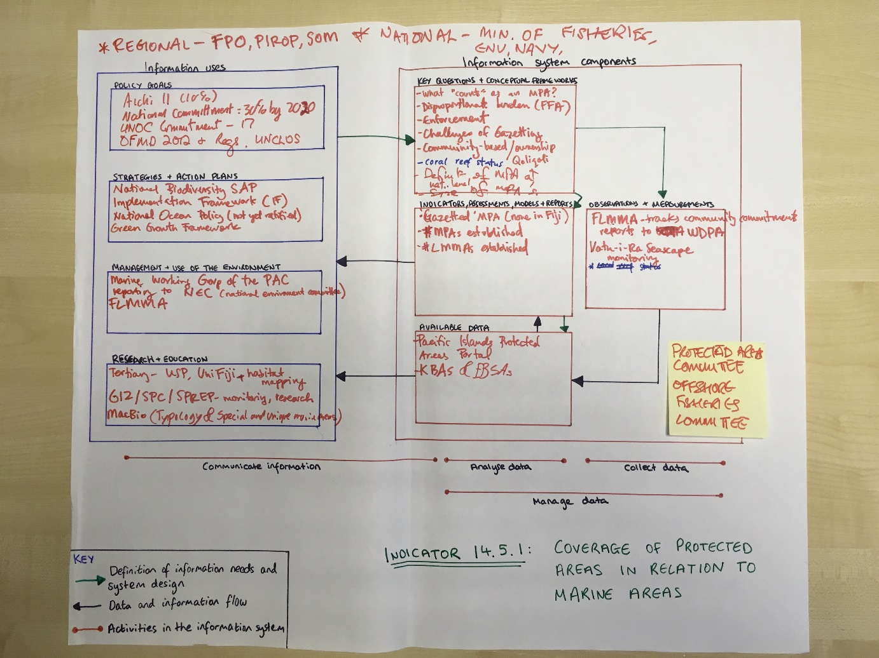

*Figure 5. Data flow, indicator producers and users for Fiji for Indicator 14.5.1. Coverage of protected areas in relation to marine areas*

Users of data and data-derived information at the national level

The primary users of data and data-derived information related to SDG 14 indicators in Fiji, in terms of governmental organisations, are the Ministry of Environment, Ministry of Fisheries and Bureau of Statistics (FBS). Although currently the FBS is not compiling specific SDG focussed information on oceans, there is likely to be a need in the near future. There is increased prioritisation and Fiji’s presidency of the 23rd Conference the Parties (2017) under the United Nations Framework Convention on Climate Change may have increased incentive and support for oceans related data. Other organisations like SPREP, IUCN and GIZ with the MACBIO project are also important data users and realise the value of such an approach. Currently, FBS collects information from stakeholders, compiles it and does regular releases. They have been working on national economic accounting and, as part of this, have released data on waste, water and energy, but none of these date are fully related to what is needed for the indicators under consideration, although it is a step in a useful direction. FBS do have a new unit responsible for cross-cutting data that do not fit into existing national themes, and so there is a chance this recent addition might be relevant for data related to the Life below water SDG indicators.

In terms of priority targets and indicators, as mentioned earlier in this document, 14.1.1 is not one of the 109 Pacific indicators that the Pacific SDGs Taskforce (PST) together with the Pacific Statistics Steering Committee (PSSC) have chosen. It is unclear how much this will impact Fiji’s approach with regard to data collection and use, and the regional approach overall.

In terms of linkages between SDG indicators and national indicators, currently there is little alignment but the government is looking at how it can use new statistics to aid SDG monitoring, e.g., in one instance with national development planning and bridging the gap to SDGs. As part of the sustainable ocean initiative process (in 2016), a total of 97 indicators were found to apply to oceans, so there are issues of harmonisation and coordination; as mentioned previously the complexity of the indicator process sometimes makes addressing the most relevant aspects a challenge. Other organisations like SPC are aligning to the SDG targets in some way, with plastic pollution and MPAs, however, the indicator process is in early days and still more regional than national. As above, additional data are needed to meet national level standards.

In terms of reporting, responsibility seems to lie with the Ministry of Fisheries and Ministry of Environment but, currently, no known indicator, target or element of either are being directly reported on. As described in the sections above under each of the three indicators, data availability was often an issue. Data comparability is another issue if methodology across time, sites or organisations is not compatible. Technology, in terms of isolated locations and lack of bandwidth and internet access, impacts data exchange and communications as well, affecting overall ability to use and assess data from various sources (including government sectors, industry, NGOs and academia) and apply them to targets.

What to include in the Global Manual on Ocean Statistics

We asked interviewees for their opinion on what they would expect to see in a Global Manual on Ocean Statistics, and for their overarching recommendations and advice they would give to governments, institutions and organisations in other countries on how to organise data flows for SDG reporting, how to implement the indicators, to how to report on the targets. A summary of suggestions follows:

* consider having one central authority outside the central realm who oversees, hosts and provides infrastructure and to whom everyone feeds information
* note that collaboration is key (and should be improved, especially cross-sectoral) – between government, ministries, and stakeholders, and clear knowledge of which SDG can be informed by whom and who should report on what
* targeting data collection is necessary and harmonisation of collection and processes to get what data are most needed, not simply what may be simplest to obtain
* ensure clear definitions on typology are given to increase efficiency and validity
* building of a national database is important to the overall process and will enable reporting
* despite data issues in terms of compatibility, a lot of data exist so try to make better use of what already exists, e.g., consider cross-sectoral approaches, management infrastructure, repositories so that bottlenecks are not only at the collection level
* advise on how to best use statistics (also those that are already being collected/produced) as an indicator
* run training and educational workshops and build more relevant material into national curricula
* provide support to governments and national agencies for better knowledge, understanding and application of indicator and target monitoring
* provide advice for countries on how to also best use and build on existing regional arrangements (where this is appropriate, like in the Fiji case), how to build this capacity to collect best practice data that feed into analyses and monitoring – the regional roles are important as they can provide additional capacity
* ensure that the data collected and processed inform policy and impact the process of its development and application; additionally provide a focus on environmental indicators (vs. social and economic as so often) to ensure that the environment plays a bigger role, in line with reality

A few additional challenges in producing a valuable guide should be considered:

* achieving the correct (and useful) balance between generic guidance and specific local contexts - consultations are critical with an overall focus on the most universally relevant issues
* making local (national) something that is global - ensure it is useful for specific, national contexts, by inclusion of multiple options for approaches so most relevant ones can be taken up
* progress on data sharing and data availability varies a lot by and within countries – improving this and encouraging data sharing and openness together with collaboration is important

The suggestions provided above focused on the needs of national institutions, with consideration of the role of regional organisations additionally, for the effective implementation of indicators for reporting progress towards SDG targets 14.

References

WEBSITES

http://dx.doi.org/10.1111/conl.12060 (accessed Nov. 29, 2017)

http://www.mpatlas.org/region/nation/FJI/ (accessed Nov. 29, 2017)

http://www.namena.org (accessed Nov. 29, 2017)

http://oceancolor.gsfc.nasa.gov/cms/ (accessed Nov. 29, 2017)

http://www.oracle.ugent.be/ (accessed Nov. 29, 2017)

http://pifsc-oceanwatch.irc.noaa.gov/erddap/griddap/OceanWatch_aqua_chla_monthly.graph (accessed Nov. 29, 2017)

https://protectedplanet.net/country/FJI (accessed Nov. 29, 2017)

http://www.seagrasswatch.org/Info_centre/Publications/pdf/Seagrasses_of_the_Fiji_Islands_2007.pdf (accessed Nov. 29, 2017)

http://www.sprep.org/attachments/VirLib/Global/ecologically-biologically-significant-marine-areas-ebsa-cbd-2014.pdf (accessed Nov. 29, 2017)

https://www.usp.ac.fj/index.php?id=18190 (accessed Nov. 29, 2017)

PUBLISHED MATERIAL

Department of Environment, Fiji (2014). Fiji’s Fifth National Report to the United Nations Convention on Biological Diversity. 102pp

McKenzie, L.J. and Yoshida, R.L. (2007). *Seagrasses of The Fiji Islands: Review Of Current Knowledge*  in ‘Seagrass-Watch: Guidelines for MonitoringSeagrass Habitats in the Fiji Islands’. Proceedings of a training workshop, Corpus Christi TeachersCollege, Laucala Bay, Suva, Fiji, 16th June 2007 (Seagrass-Watch HQ, Cairns). 42pp

Pacific Regional Preparatory Meeting towards the UN Ocean Conference Regional Working Discussion Paper – PRPM-UNOC (2017). Our Sea of Islands – Our Livelihoods – Our Oceania. Preparatory document for meeting March 2017

Posa A. Skelton & G. Robin South (2006) Seagrass biodiversity of the Fiji and Samoa islands, South Pacific, New Zealand Journal of Marine and Freshwater Research, 40:2, 345-356, DOI: 10.1080/00288330.2006.9517426 (http://www.tandfonline.com/doi/pdf/10.1080/00288330.2006.9517426)

Secretariat of the Convention on Biological Diversity (SCBD) (2014). Ecologically or Biologically Significant Marine Areas (EBSAs). Special places in the world’s oceans. Volume 1: Western South Pacific Region. 104 pages (http://www.sprep.org/attachments/VirLib/Global/ecologically-biologically-significant-marine-areas-ebsa-cbd-2014.pdf)

Secretariat of the Pacific Community (2015). A new song for coastal fisheries – pathways to change: The Noumea strategy. Developed by participants at the Future of Coastal/Inshore Fisheries Management Workshop 3–6 March 2015, Noumea, New Caledonia https://womeninfisheriesfiji.org/wp-content/uploads/2016/10/New_song_for_coastal_fisheries-Anon_2015_.pdf)

PERSONAL COMMUNICATION

Cherie Morris (USP), Nov. 23, 2017, in written communication

Ministry of Fisheries, Nov. 1, 2017, Offices of the Ministry of Fisheries

Annexes

Annex 1 Fiji Case Study Visit Agenda

**Assessing the availability of data and indicators in Fiji for a compilation of best practices in measuring the oceans through a case study approach**

Agenda

**Day 1**

*Wednesday 1 November (Ministry of Economy | Fiji Bureau of Statistics)*

**Morning: Opening Session with all stakeholders** (Fiji Bureau of Statistics, Conference Room)

10:00 – 11:00 Introduction: Welcome by Mr. Epeli Waqavonovono (FBS); Introduction by Elisabetta Bonotto - The SDGs Monitoring and Reporting Process, UN Environment role, the Global Manual on Ocean Statistics to track progress against SDG 14 (Life below water).

11:15 – 12:45 Introduction and explanation of data/indicators mapping exercise by Fiona Danks (UNEP-WCMC): This exercise will help to identify priorities, existing/available data and indicators, and data gaps in Fiji. It will also serve to map out, for each SDG indicator (14.1.1, 14.2.1, and 14.5.1), data information flows and responsible/contributing institutions.

12:45-13:00 Wrap-up

**Afternoon: Interviews** *(IUCN, GIZ, SPREP, Fiji Bureau of Statistics)*

14:15 – 15:30 IUCN, GIZ and SPREP (MACBIO project)

15:45 – 17:15 Fiji Bureau of Statistics

**Day 2**

*Thursday 2 November (USP, WCS, CME, MEDIN, WWF)*

**Interviews**

10:30 – 12:00 University of the South Pacific (USP)

13:00 – 14:00 Wild Conservation Society (WCS)

14:30 – 15:30 Commonwealth Marine Economies (CME) - Marine Environmental Data and Information Network (MEDIN)

16:15 – 17:00 Worldwide Fund for Nature (WWF) Pacific

**Day 3**

*Friday 1 November (SPREP, SPC, MoF, PIFS)*

**Interviews**

09:45 – 11:30 SPREP – Samoa team (Skype interview)

12:00 – 13:30 Pacific Community (SPC)

14:00 – 15:00 Ministry of Fisheries (MoF)

15:00 – 16:30 Pacific Islands Forum Secretariat *(*PIFS)

**Contacts**

**Elisabetta Bonotto**

UN Environment – Science Division

Email: [Elisabetta.Bonotto@unep.org](mailto:Elisabetta.Bonotto@unep.org)

**Fiona Danks**   
UN Environment World Conservation Monitoring Centre

Email: [Fiona.Danks@unep-wcmc.org](mailto:Fiona.Danks@unep-wcmc.org)

**Katherine Despot-Belmonte**    
UN Environment World Conservation Monitoring Centre

Email: [Katherine.Despot-Belmonte@unep-wcmc.org](mailto:Katherine.Despot-Belmonte@unep-wcmc.org)

Annex 2 Fiji Case Study Visit – List of Workshop Attendees and Interviewees

|  |  |  |  |
| --- | --- | --- | --- |
| **Institution** | **Attendee** | **Workshop** | **Interviewed** |
| **Fiji Bureau of Statistics** | Epeli Waqavonovono |  |  |
|  | Litia Kurisaqila |  |  |
| **Fiji Ministry of Environment** | Eleni Tokaduadua |  | *via email* |
| **Fiji Ministry of Fisheries** | Aisake Batibasaga |  |  |
|  | Leilani Kotobalavu |  |  |
|  | Richard Veeran |  |  |
|  | Nanise Kuridrani |  |  |
| **PIFS** | Ribanataake Awira |  |  |
|  | Jeremy Hills |  |  |
| **GIZ-MACBIO** | Philipp Gassner |  |  |
|  | Hans Wendt |  |  |
| **SPREP** | Tommy Moore |  |  |
|  | Herman Timmermans |  |  |
|  | Paul Anderson |  |  |
|  | Amanda Wheatley |  |  |
|  | Anthony Talouli |  |  |
|  | Vainuupo Jungblut |  |  |
|  | Warren Lee Long |  |  |
| **SPC** | Malakai Vakautawale |  |  |
|  | Molly Powers-Tora |  |  |
| **USP** | Jeremy Hills |  |  |
|  | Marta Ferreira |  |  |
|  | Cherie Morris |  |  |
| **UNESCAP** | Sanjesh Naidu |  |  |
| **WCS** | Sangeeta Mangubhai |  |  |
|  | Yashika Nand |  |  |
|  | Jone Tamanitoakula |  |  |
| **WWF Pacific** | Rusila Savou |  |  |
| **MEDIN** | Clare Postlethwaite |  |  |

1. See the National Development Plan 2014-2018 (in Spanish) here: <https://www.dnp.gov.co/Plan-Nacional-de-Desarrollo/Paginas/Que-es-el-Plan-Nacional-de-Desarrollo.aspx>
2. The Regional Autonomous Corporations (CAR in Spanish) are the primary environmental authority at the subnational level (i.e. municipalities) in Colombia
3. *The High Level Commission for Enlistment and Effective Implementation of Agenda 2030 and its SDGs* (a.k.a. SDG Commission) was created under Decree 280 of 2015
4. **14.1**: By 2025, prevent and significantly reduce marine pollution of all kinds, in particular from land-based activities, including marine debris and nutrient pollution. **14.2**: By 2020, sustainably manage and protect marine and coastal ecosystems to avoid significant adverse impacts, including by strengthening their resilience, and take action for their restoration in order to achieve healthy and productive oceans. **14.5**: By 2020, conserve at least 10 per cent of coastal and marine areas, consistent with national and international law and based on the best available scientific information.
5. Data-producers for indicators 14.1.1, 14.2.1, and 14.5.1 are INVEMAR, Natural National Parks (PNN) and the local environmental authorities’ a.k.a. Regional Autonomous Corporations (CAR)
6. The Regional Autonomous Corporations (CAR in Spanish) are the primary environmental authority at the subnational level (i.e. municipalities) in Colombia
7. National Aeronautics and Space Administration (USA)
8. National Oceanic and Atmospheric Administration (USA)
9. More information on NOAA’s Marine Debris Program available here: <https://marinedebris.noaa.gov/>; marine debris monitoring and assessment <https://marinedebris.noaa.gov/sites/default/files/Lippiatt%20et%20al%202013.pdf>; and shoreline survey and field guide <https://marinedebris.noaa.gov/sites/default/files/ShorelineFieldGuide2012.pdf>
10. The National Environmental Policy for the Sustainable Development of Ocean Spaces, Islands and Coastal Areas(PNAOCI), is available in Spanish here: <http://www.minambiente.gov.co/images/BosquesBiodiversidadyServiciosEcosistemicos/pdf/Normativa/Politicas/4268_161009_polit_zonas__costeras_pnaoci.pdf>
11. UNESCO’s Methodological Guide to ICZM: <http://unesdoc.unesco.org/images/0012/001245/124596eo.pdf>
12. More information about this indicator is available in Spanish here: <http://www.invemar.org.co/redcostera1/invemar/docs/ier2014.pdf> pages 123-127
13. INVEMAR manages SIGMA (<http://sigma.invemar.org.co/> ), which is an information system for the sustainable management of mangroves.
14. See Article 7 of Decree 2372 of 2010, Decree 3572 of 2011 and Decree 1076 of 2015
15. RUNAP <http://runap.parquesnacionales.gov.co/>
16. On 15th of September 2017 Colombia declared the expansion of the Malpeo sanctuary and the Yurpari-Malpeo district in the Pacific region, increasing Colombia’s total MPA coverage from 8.50% to 13.31%. See <https://newsroom.wcs.org/News-Releases/articleType/ArticleView/articleId/10509/Colombia-Declares-More-Than-4-Million-New-Protected-Hectares-Achieves-Conservation-of-1331-Percent-of-Coastal-Marine-Area.aspx>
17. See Decree 347 from 2000 on the role and functions of the Colombian Commission of the Ocean (CCO): <http://www.cco.gov.co/images/documentos/Decreto_347_2000.pdf>
18. See the National Policy on Oceans and Coastal Spaces (PNOEC in Spanish): <http://www.cco.gov.co/docs/publicaciones/pnoec-2017-03.pdf>
19. The interest of CCO in applying the OHI in Colombia and the potential use of SDG 14 indicators was discussed in an interview via Skype with CCO officials, names of interviewees are available in Annex 2 of this report
20. Open access geospatial data repository for the Pacific Region providing premier geophysical, geodetic, and marine spatial data sets
21. Global Ocean Observing System (United Nations Educational, Scientific and Cultural Organization - Intergovernmental Oceanographic Commission)
22. Marine and Coastal Biodiversity Management in Pacific Island Countries (joint project by SPREP, IUCN and GIZ)
23. Exclusive Economic Zone