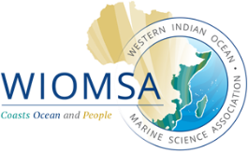
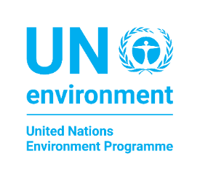
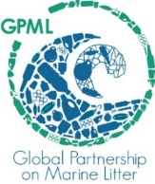
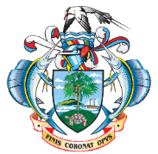

Final Participants List

National Marine Litter Data Collection Training in Seychelles
26 August to 04 September 2019
Mahé Island, Seychelles

Julio Moustache
Marvis Keddy Estico
Francisca Veronica Hollanda
Patrick Dubois
Dainise Lyne Quatre
Amina Giselle Furneau
Ricky Nigel Simeon
Marie-Antoinette Micock
Ronny Joseph
Jude Moustache
Ryley Barbe
Marcus Moumou
Camilla Labonte
Farida Moncherry
Alison Lucas
Victoria Alis

